COP 4232
Software Systems Development

Specification

For the

Classroom Simulation System (CSS)

© Dr. David A. Workman
School of Computer Science
University of Central Florida
Computer Science Department
Orlando, Florida

November 10, 2003
Revised: May 14, 2004
I.1 Introduction: Problem Definition

Figure 1 illustrates the “virtual world” of a typical classroom situation. Simulating this virtual world will be one of the project options we will discuss in more detail later in this course. In the interim, however, this setting will provide the motivation and source of requirements for individual programming assignments leading up to the project.

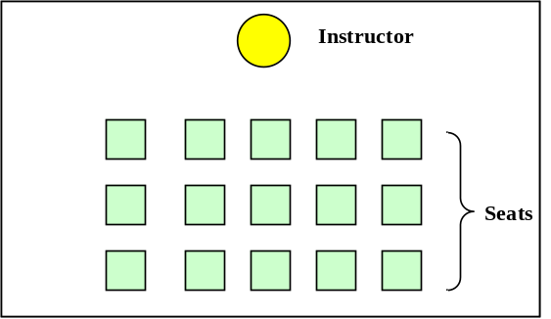
Figure 1. Virtual Classroom

This classroom scenario consists of an instructor together with a group of students gathered in a classroom. The classroom session begins when the instructor arrives (enters the classroom) and begins making preparations for delivering the lecture topic. (You can use our class as a realistic model for this activity.) During the lecture, the instructor presents concepts of varying difficulty to comprehend. Concepts are supported by facts and illustrated by examples. Students differ in their ability to grasp concepts and remember facts. Because of the level of concept difficulty and a student’s imperfect ability to grasp concepts and remember facts, a student may interrupt with questions about lecture material.

The lecture session continues until halfway through the class period. At the midpoint, the instructor conducts a snap quiz covering the material presented during lecture. Quiz papers are handed out to the students and each student takes the quiz by writing their names on the paper and then sequentially answering questions about concepts using what they have learned from lecture. When a student has completed the quiz, he or she hands it to the instructor and leaves the classroom. As time remaining approaches an end, the instructor gives periodic alerts. When time runs out, all students must immediately terminate their question answering scenario and hand in their quiz – finished or not. After all students have left the classroom, the instructor leaves the classroom with all quizzes. The simulation ends when the instructor leaves the classroom.

I.2 Problem Analysis

We begin an object-oriented analysis of the problem scenario by looking for objects and their relationships. Objects are most easily identified by “nouns” that appear in the problem description. In our virtual classroom, the following objects are immediately identified: classroom, instructor, students, lecture topic, concepts, facts, examples, questions, answers, quiz papers. With this initial list of objects we can immediately separate them into two groups – active and passive. Passive objects are benign and inanimate. They hold information or other objects, and they tend to be the focus of manipulation by the active or animate objects in the system. Animate objects function on their own energy or power and exhibit a behavior – perform some series of actions on other objects in the problem. Clearly, our active objects in the virtual classroom are the instructor and the students. All other objects in the classroom are passive. In our simulation, active objects will be called agents.

Now we ask, what do we know about objects and their relationships? To identify all pertinent information about objects and their relationships, we must frequently infer or deduce properties based on our own intuition and real world experience, and not just on information stated in the problem statement. Here is a list of the most obvious relationships that are stated or implied by our problem scenario:
- The classroom contains the instructor and students and defines the boundary of the virtual scenario we’ve just described.
- A lecture topic is composed of concepts, facts and examples.
- Concepts have a comprehension difficulty factor.
- Concepts have associated facts and examples.
- The instructor prepares for lecture.
- The instructor delivers a lecture topic.
- The instructor distributes and collects quizzes.
- The instructor announces time remaining during the quiz period.
- Each student is characterized by his or her comprehension ability.
- Each student remembers concepts and facts based on the concept difficulty and their comprehension ability.
- Students ask questions about lecture concepts.
- The instructor answers questions by repeating facts and examples.
- Students have a name.
- Students take a quiz by answering questions.
- A quiz is composed of a student name, a list of questions, and the student’s response to each question.

A property or properties that appears to characterize an object (distinguish it from other objects) are called attributes. Students and the instructor have a name (we infer that the instructor has a name from our real world experience). Students have a comprehension factor. Concepts have a difficulty factor.

Finally, the scenario “plays out” as a result of actions performed by agents or interactions between agents in the virtual world. Actions performed by an agent characterize its behavior. Behavioral requirements will ultimately serve to define the methods an agent must define (as a software entity). Behavioral properties are not limited just to agents. Passive objects must support operations that store and retrieve the information they hold, and perhaps perform computations to derived information they do not directly hold in a persistent form.

I.3 Specification in UML

In the previous section we performed an informal initial analysis of our virtual classroom scenario. In this section we want to introduce UML as a more formal notation for capturing information about the problem and its solution.

Figure 2 expresses the class – subclass relationship in UML. This relationship is also termed the “Is-A” relationship meaning that every member of the subclass “is a” member of the superclass. This relationship is also called “generalization – specialization” (Gen-Spec), suggesting that the constraints defining membership to the subclass is a specialization of the constraints defining membership to the more general superclass. The concept of “inheritance” is implicit in the class-subclass relationship. Members of a subclass inherit all the characteristics, properties and behaviors found common to members of the superclass.

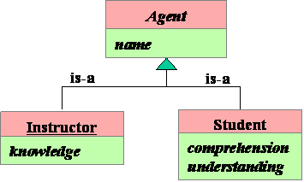
Figure 2. Agent Relationships in UML.

Figure 2 is an example of a UML Class diagram. It expresses the fact that Instructor and Student are specialized types of Agent. The class name, Agent, is expressed in italics, suggests that the class is abstract (no instances exist in the problem). Student and Instructor, on the other hand, are concrete objects (they do exist in the problem). The convention of underlining the class name (as indicated for Instructor) is used to indicate that only a single instance of that class exists in the problem. Regarding the relationships among these classes: all Agents have a name; Instructors have knowledge (of the lecture topic), but Students do not (at least not before the lecture). Students have comprehension that determines their ability to learn and acquire understanding; “understanding” can be thought of as an intermediate state of “knowledge” – qualitatively, the two concepts are different. Through the lecturing process, the Instructor imparts knowledge to the Students in the form of understanding. Of course, both represent a type of “memory” used to retain this information.

Another important relationship we identified in our analysis is the Container-Containee relationship. This is formally called the Aggregation relationship. This relationship holds between the Classroom and the Agents. This relationship would also extend to any furniture in the classroom, such as desks and chairs, a computerized projection system, etc. Since these are really not mentioned in our problem, nor are they explicitly relevant in our simulation models, we do not show them in the Class diagram shown in Figure 3.

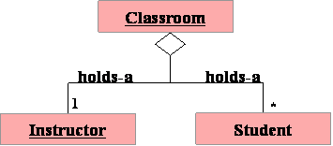
Figure 3. Aggregation Among Objects in the Classroom

Notice that the aggregation connector is annotated with a “1” above “Instructor” and with a “*” above “Student”. These multiplicity annotations indicate the number of class instances of Instructor and Student that enter into the aggregation relationship with each instance of Classroom.

The third UML relationship is that of Composition illustrated in Figure 4 between Topic, Concept, Fact, and Example, and between Quiz and its constituent parts.

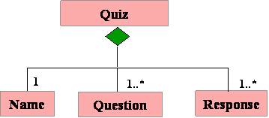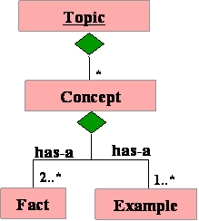
Figure 4a. Quiz Composition Figure 4b. Topic Composition

The final UML relationship we illustrate is that of Association as shown in Figure 5 between Instructor and Topic, between Instructor and Student, and between Instructor, Student and Quiz. Association is used when none of the above relations of Gen-Spec, Aggregation, or Composition apply and where there must be some type of interaction between related objects or class instances.

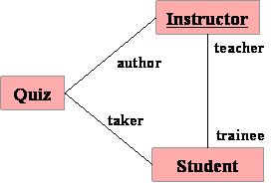
Figure 5. Associations Among Quiz, Instructor and Student
I.4 Detailed Requirements

The Instructor
The agent model for the Instructor shall support the following functional behaviors:
- Preparing for lecture to include such actions as turning on the computer projection system, pulling down the projection screen, etc. The model shall include attributes that define the amount of time (in “clock ticks”) it takes the Instructor to perform each preparation activity. These times can be randomly generated or directly defined from input parameters at runtime.
- Delivering the lecture topic to include such actions as defining concepts, stating facts, and illustrating principles with examples, each requiring varying amounts of time to deliver; concepts should have a definition time parameter, a level-of-difficulty parameter and an associated set of facts and examples – total concept delivery time should be a function of the size of the fact and example sets. Each concept delivery period is followed by a question-answer period that may vary in length according to the difficulty of the concept presented. During this period, the instructor answers questions only about the associated concept by repeating the presentation of a subset of the facts associated with the concept. The repeated fact subset is based on questions asked by students together with simulation parameters defined by the developer. Questions about other concepts and questions asked by students outside the allocated Q&A period are ignored by the instructor. If no questions occur within the first 25% of the question period, the instructor announces the end of the question period and moves on to the next concept.
- Announcing the examination period and passing out quizzes to students.
- Monitoring and managing the examination time; giving periodic announcements when nearing the end of the examination period.
- Collecting the completed quizzes and making sure that all quizzes have been turned in with the students name written on the quiz paper before leaving the classroom.
- Grading the quizzes.
- Ensuring that no more than one hour (a class period) is spent on lecture and examination.
The Students
A student scenario begins when he or she enters the classroom. Most students arrive on time (start of class), but need not. During the lecture segment the student shall listen to lecture material and remember some or all the facts about concepts. A fact is easier to retain (probability of loss or misunderstanding decreases) as the number of examples used to illustrate the fact increases, but the benefit of additional examples diminishes non-linearly. A student’s overall ability to grasp concepts (comprehension, 0 ≤ C_{s} ≤1, where “s” identifies the student) improves their ability to retain the facts presented, but a concept’s difficulty decreases their retention ability.

During a question period associated with each concept, the instructor asks for questions about the concept. Each student may ask at most one question about the facts presented for a given concept, but only about facts they did not comprehend. A student’s question identifies a single fact and the instructor determines what facts asked by students should be repeated based on the amount of time available and the number of students asking to repeat the fact.

Once the examination period begins, each student waits for a copy of the quiz to be passed from the student sitting ahead of him/her in the same seating column. The instructor gives the student in the first row of each column enough copies of the quiz to service the entire column. When a student has received a copy of the quiz and passed the remaining copies to the person seated behind him/her, the student begins taking the quiz. If a student is not in their seat (because of late arrival to class) at the time quizzes are handed out, the student does not receive a quiz and is asked to leave class by the instructor.

The quiz scenario begins with the student writing their name on the quiz paper. Then a student begins answering questions. All questions are of the form: “To what concept does fact (f) belong?”. If the student recognizes the fact, he or she responds with the correct concept. If the fact does not belong to the set of facts the student knows, then the student must record the answer, “unknown.” When all questions have been answered, the student hands in the quiz and leaves the classroom. A student’s score on the quiz is the percentage of correct answers relative to the total number of quiz questions.

Simulation Input File
The simulation input file shall follow the OO Data Protocol presented in an earlier document. A sample input file is illustrated below.

Classroom{
#rows: int
#cols: int
#students: int // #students <= #rows * #cols
classLength: int //clock ticks
Instructor{
prepDelay: int
GradingDelay: int //per quiz question
Lecture{
#concepts: int //optional
Concept{
Name: string
Difficulty: real //original
Q&APeriod: int // function of difficulty
#facts: int //original = M_{k}
Fact{ id: string
#examples: int //
exDelay: int //per example
}Fact
…
}Concept
…
}Lecture
Quiz{ Name: string //filled in by student
#Questions: int //optional

Question{ Fact: string //unique fact name
Answer: string //concept name filled in by student
}Question
…
}Quiz
}Instructor
Student{ Name: string
TOA: int //Time of arrival to class
AnsDelay: int //Time delay for answering quiz questions
Comprehension: real
Score: real // filled in (computed) instructor after grading
// facts and concepts learned must be maintained by students
}Student
…
}Classroom

Simulation Output
The simulation output is structured according to the pre-defined OO Output protocol and contains the standard information enumerated below.
- Simulation heading identifying the development team and the run date and time.
- State of virtual world before simulation begins.
- Log of simulation events.
- State of virtual world after simulation ends.
- Post simulation report containing the following items:
(a) Number of student taking the quiz.
(b) Total number of students.
(c) For each Concept give the following items:
- Delivery time for concept presentation
- Number of questions by students.
- Number of facts delivered (original presentation)
- List of facts delivered (Q&A )
- Total Q&A time

II.1 A General Object Oriented Design for Discrete Event Simulation

This section provides an overview of the architecture for a generic discrete event simulation. Figure A-1 illustrates the major functional components. Among the four components shown, only SimModels is application specific. All other components can be reused as is.

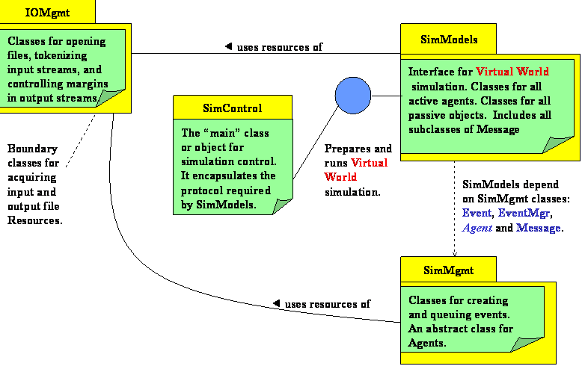

Figure A1. Package Architecture for Discrete Event Simulation

II.2 Namespace IOMgmt

This package (namespace) iomgmt provides reusable classes for identifying and opening existing ASCII input and output files. Class IOMgr provides a method, getFileName, that takes a prompt message as a parameter and conducts a dialog with the user via the standard input (keyboard) and output (screen) boundary objects. IOMgr also provides methods for opening files as input or output and raises (throws) an instance of exception, IOError, if the open operation does not succeed for the identified file. As a convenience to clients, IOMgmt provides a pre-defined instance of class IOMgr called, theIOMgr. This single instance is visible everywhere IOMgmt is visible.

IOMgmt also provides a boundary class, Tokenizer, to provide a logical view of ASCII input files as streams of tokens as opposed to streams of characters or lines. In this view, the input file is an alternating sequence of delimiter strings and token strings, optionally beginning and ending with a delimiter string. Delimiter strings and token strings are composed from disjoint alphabets. The user can change the alphabet for delimiter strings at any time by a call to SetDelims(), the default alphabet is {blank, tab, EOL}. The token alphabet is always the complement of the delimiter alphabet. To obtain the next pair (delimiter, token) from the input stream, the client calls method Scan(). If no token exists in the input stream, Scan() returns the null string. If the client wishes to examine the delimiter string discarded by Scan(), it may do so by calling the method Discard() before the next call to Scan(). The delimiter string could be null on the first call to Scan. The method More() is a boolean function that returns false once the end-of-file has been sensed.

Tokenizer interacts with the user to define the name of the input file using a pre-defined instance of IOMgr, theIOMgr, defined by the namespace, IOMgmt. If the input file is not found or the open is unsuccessful for some reason, Tokenizer raises (throws) an instance of exception IOError.

IOMgmt also provides class, StringTokenizer. This class offers the same logical functionality as class Tokenizer except that it operates on string objects instead of an input streams. StringTokenizer is frequently useful for further tokenizing the discard and token strings returned by a Tokenizer.

II.3 Namespace SimMgmt

Figure A2 illustrates in UML the functional layers of classes comprising SimMgmt and SimModels. The four classes, Event, EventMgr, Agent and Message, are application independent and define the infrastructure or framework classes necessary to support any simulation.

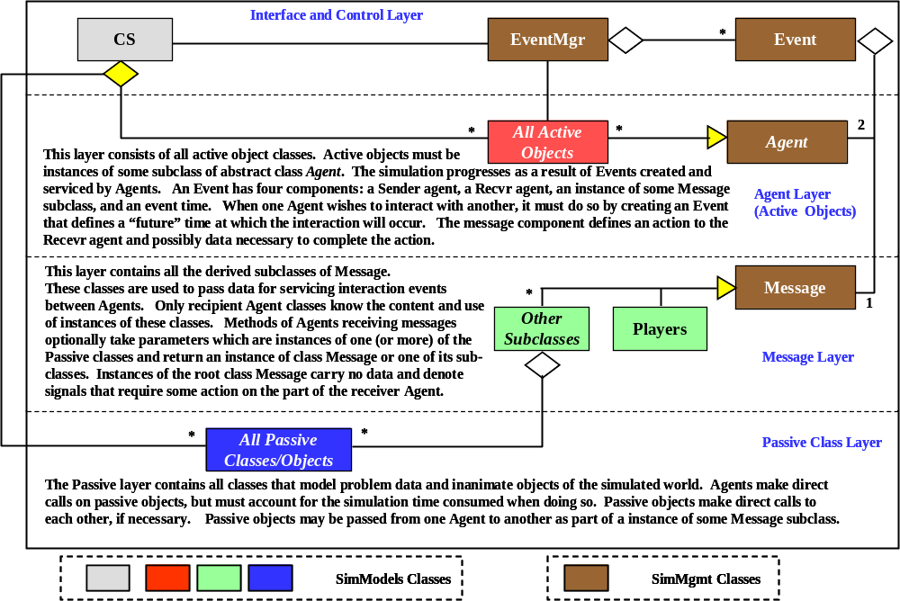
Figure A2. Layered Class Architecture for Discrete Event Simulation
Class Agent: Agent is an abstract class. This implies two facts about Agent. First, no instances of Agent can be created by the application. Second, and its primary purpose, is to impose constraints on all concrete derived subclasses – it is, in effect, a software contract enforced by C++. Abstract classes in C++ are defined by including at least one pure virtual method in their specification or declaration. The pure virtual methods for Agent are identified by comments in the header file, “simmgmt.h”.

All instances of its derived subclasses must communicate (and only communicate) with one another by sending instances of Message, or one its derived subclasses, via Events. That is, a sender agent requests an action of some receiver agent by creating and posting, via EventMgr, an instance of Event that defines the future time at which the Message instance is to arrive at the receiver. All potential sender and receiver objects must be instances of derived subclasses of class Agent.

Class Message: Message classes are used to request actions and pass data between Agents. Messages encapsulate the identity of an event handler (handler) the receiver Agent will call to service (respond to) the message when its corresponding Event “occurs”. The handler id is a non-negative integer value known only to, and interpreted by, the receiver Agent. Subclasses of Message may also be defined to encapsulate specific data that must be transmitted with the message to enable the handler to properly service the message. The base class, Message, is a concrete class that carries no data, it is used to request actions that are triggered by a simple signal or notification that the sender wishes to convey to the receiver. The naming convention suggested for subclasses of Message is the following, <datatype>Msg, where <datatype> is an identifier that describes what kind of data the message is carrying and implicitly what its purpose or semantic content is relative to application. For example, in the Classroom simulation, when a student wishes to ask the instructor a question, the student (sender Agent) would create an instance of QuestionMsg, to carry the string data forming the question to be asked of the instructor (receiver Agent). Clearly the name StringMsg, although technically correct, does not convey the meaning of the string data being conveyed. Keep in mind that QuestionMsg is a subclass of base class Message and therefore inherits the “handler” code – the assigned handler for this subclass interprets the data being sent and implicitly gives this data its meaning or purpose.

Class Event: An Event instance is an object by which instances of class Agent interact with each other. Its purpose is to bind a simulation time to the arrival of a Message instance to a receiver Agent. It also identifies the sending Agent. Because Events must be ordered by simulation time, it is necessary to overload the Boolean relational operators for this class.

Class EventMgr: EventMgr encapsulates the event queue and orders events according to their simulation time stamp. The clock() function always returns the current simulation time. This class shall be implemented using the STL (C++ Standard Template Library) class list. Furthermore, a global variable called theEventMgr shall be created in the implementation file for simmgmt to represent the one and only instance of class EventMgr for purposes of simulation.

Class AppErrors: This is the base exception class for generating error exceptions raised during a simulation. In C++ an instance of any class can be “thrown” as an exception. AppErrors is pre-defined to provide convenient error diagnostic and reporting services to simulation classes. Every instance of this class contains two data members: one that define the origin of an exception (in what method and class?) and a message string that diagnoses the cause of the exception in the originating method. The values of these data members can be obtained by calls to methods: getMsg() and getOrigin(). As the exception travels up the call chain, each exception handler ( catch block ) has an opportunity to append additional information to the origin and message data members; this is accomplished using the methods appendOrigin() and appendMsg(). After updating the exception content, the handler re-throws the exception so that it may be propagated upward along the call chain to some point where the exception can be properly dealt with, or to a point where the program can or must be terminated (e.g. main()). At the highest level of control, just before the program terminates, the origin and message members of the exception can be output to provide a trace of the call chain and a diagnosis by each method that handled (caught ) the exception along this chain.

II.4 Namespace SimModels

This namespace encapsulates all classes that model simulated entities. We use the term “virtual world” or “virtual object” to refer generally to the situation or scenario being simulated, but more specifically to a unique instance of the VirtualWorld class. When you, the simulation application developer, design and implement a new simulation, you will re-define most of the methods of the VirtualWorld class to make them specific to the new simulated reality. In addition, you will have to design and develop a specific collection of subclasses of Agent to model the active objects in your virtual world and a collection of standalone classes to model the passive objects in your virtual world. Finally, you will need to define and implement the derived subclasses of Message necessary to support the set of interaction events that occur among agents in the simulated world.

One of the special Message subclasses that will need to be designed is subclass Player. The Player class is a special-purpose class required to initialize all agents prior to the actual simulation execution at runtime. An instance of this subclass holds pointers to all agents and passive objects that must be created prior to simulation execution. More precisely, every agent must have a pointer to itself and to any other agent with which it needs to communicate with via message passing. There may also be certain passive objects to which agents may need access before simulation begins. Pointers to these objects must also be added to a Players instance. During the initialization phase of virtual world construction, each agent is passed the instance of Players. Using service methods of Players, each agent retrieves the pointers to other agents and passive objects it needs access to.

